Week 6 report of Internship

Ammar Akram
Name

DVS-8041
ID

Machine Learning
Domain

Ofiice
Devsphere

16/10/2026
Date

DEVSPHERE AI & ML INTERNSHIP

BREAST CANCER DIAGNOSTIC PREDICTION SYSTEM:

1. Abstract :
The Breast Cancer Diagnostic Prediction System is an end-to-end machine learning project developed for the Week 6 final project of the DevSphere AI & Machine Learning Internship. The purpose of this project is to demonstrate how a machine learning workflow can be designed, trained, evaluated, visualized, and integrated into an interactive application.
The project uses the Breast Cancer Wisconsin dataset available through Scikit-learn. It contains 569 observations and 30 numerical input features associated with two original dataset classes: malignant and benign.
The implementation covers dataset exploration, data preprocessing, training and testing data separation, Logistic Regression and Random Forest model development, performance comparison, hyperparameter optimization, model evaluation, and graphical visualization. GridSearchCV is used to tune Logistic Regression through five-fold cross-validation. The selected estimator is then evaluated on a separate test set.
A Streamlit application provides an interface for entering numerical feature measurements and displaying the model's predicted class and estimated class probabilities. The project also generates a serialized model, evaluation reports, a model comparison table, a confusion matrix, and an ROC curve.
Disclaimer: This project is strictly for educational purposes. It is not clinically validated and must not be used for medical diagnosis, treatment, or patient-management decisions.

2. Introduction :
Machine learning is a branch of artificial intelligence that enables computer systems to learn patterns from data and use those patterns to make predictions. Classification is a supervised learning task in which observations are assigned to predefined categories using their input features.
This project applies binary classification to the Breast Cancer Wisconsin dataset. Each observation contains numerical measurements describing characteristics of cell nuclei, while the associated target indicates one of two dataset classes.

3. Problem Statement :
A complete machine learning prediction system requires more than generating a classification. The data must be inspected and prepared, appropriate models must be trained, performance must be measured on unseen observations, and the results must be presented in a clear and reproducible manner.
The objective of this project is to develop a structured binary classification system that demonstrates these processes using an established dataset. The project also aims to provide an interactive interface through which numerical measurements can be entered and processed by a saved machine learning model.

4. Project Objectives :

- Load and inspect a real-world classification dataset.
- Examine the dataset's dimensions, feature types, descriptive statistics, and class distribution.
- Detect and handle missing or infinite numerical values.
- Divide the dataset into training and testing subsets.
- Train Logistic Regression and Random Forest classifiers.
- Compare the models using multiple classification metrics.
- Optimize Logistic Regression hyperparameters using GridSearchCV.
- Evaluate the selected model on a held-out test set.
- Generate a model comparison chart, confusion matrix, and ROC curve.
- Save the trained model and evaluation outputs.
- Develop an interactive Streamlit prediction application.

5. Project Scope :
The project covers supervised binary classification, numerical data preprocessing, model training, model comparison, hyperparameter optimization, performance evaluation, visualization, model serialization, and interactive prediction.
The implementation is intended to demonstrate machine learning development practices. It does not include clinical validation, hospital-system integration, patient-record management, or real-world medical decision support.

6. Dataset Description :
The project uses the Breast Cancer Wisconsin dataset supplied by Scikit-learn through its load_breast_cancer() function.
Dataset characteristic | Description
Total observations | 569
Numerical input features | 30
Target classes | 2
Learning approach | Supervised learning
Task | Binary classification
Input data type | Numerical
Dataset source | Scikit-learn

7. Tools and Technologies :
Technology | Purpose
Python | Main programming language
Pandas | Dataset manipulation and tabular analysis
NumPy | Numerical operations
Matplotlib | Graph creation
Seaborn | Statistical visualization
Scikit-learn | Dataset access, training, tuning, and evaluation
Joblib | Model serialization and loading
Jupyter Notebook | Interactive experimentation and documentation
Streamlit | Interactive prediction interface
Visual Studio Code | Code editing and project development
Git and GitHub | Version control and project publication

8. System Architecture and Workflow :
The system follows a sequence of data processing, model development, evaluation, and prediction.
Workflow:
Dataset Loading → Exploratory Data Analysis → Data Preprocessing → Train/Test Split → Model Training → Model Comparison → Hyperparameter Tuning → Final Evaluation → Model Saving → Interactive Prediction
Each stage has a defined role in preparing the data, selecting a model, assessing its performance, and making it available through the application.
8.1 Dataset Loading :
The dataset is loaded using Scikit-learn's built-in dataset loader. The input measurements are stored in a Pandas DataFrame, and the target labels are stored separately.
The feature names are preserved so that the data remain interpretable during exploration and are passed to the model in the correct order.
8.2 Exploratory Data Analysis :
Exploratory data analysis is used to understand the structure and characteristics of the dataset before training.
The process includes inspecting the first records, checking dataset dimensions and feature types, calculating descriptive statistics, reviewing class frequencies, and visualizing the distribution of target classes.
These checks help verify the dataset's structure and provide an initial understanding of the data used in the project.
8.3 Data Preprocessing :
The preprocessing stage checks for missing values, infinite values, and duplicate records. Infinite values are replaced with missing values, and missing numerical values are filled using the corresponding feature median.
The dataset is divided into training and testing subsets using an 80:20 ratio. The split uses random_state=42 to support reproducibility and stratification to preserve the approximate class distribution in both subsets.

8.4 Feature Scaling :
StandardScaler is included in the Logistic Regression pipeline. It standardizes numerical features using statistics learned from the training data.
The scaler is fitted within the pipeline, helping ensure that the transformation is applied consistently during training, testing, and subsequent prediction. This also prevents test-set information from being used to fit the scaler.
The Random Forest classifier is trained separately because tree-based models generally do not require feature standardization.
8.5 Logistic Regression :
Logistic Regression is implemented as a pipeline consisting of StandardScaler followed by Logistic Regression. The pipeline learns a relationship between the numerical input measurements and the dataset's target classes.
The model supports class predictions and estimated class probabilities. A maximum iteration limit is configured to support convergence during training.
8.6 Random Forest :
The Random Forest classifier is configured with 200 decision trees, a fixed random state, balanced class weights, and parallel processing where supported.
The model combines predictions from multiple decision trees. It provides an alternative to Logistic Regression for comparison on the same dataset and test observations.
8.7 Model Comparison :
Both classifiers are evaluated on the same held-out test set. Their results are compared using accuracy, precision, recall, F1-score, and ROC-AUC.
The comparison is saved in report/model_comparison.csv and represented graphically in screenshots/01_model_comparison.png.

8.8 Hyperparameter Optimization :
GridSearchCV is used to tune the Logistic Regression pipeline through five-fold cross-validation. The search examines the following parameter values:
Parameter | Values evaluated
classifier__C | 0.01, 0.1, 1, 10, 100
classifier__solver | liblinear, lbfgs
Cross-validation | 5 folds
Selection metric | Accuracy

8.9 Final Model Evaluation :
The selected estimator generates predictions for the test observations. Those predictions are compared with the actual test labels to calculate the final metrics.
The evaluation includes accuracy, precision, recall, F1-score, ROC-AUC, a classification report, a confusion matrix, and an ROC curve.
The final metrics are saved in report/final_evaluation_metrics.csv, and a text summary is saved in report/evaluation_report.txt.
8.10 Model Serialization :
The selected model is saved using Joblib as model/prediction_model.joblib. The saved bundle contains the trained model, ordered feature names, and target class names.
This allows the application to load the trained estimator without retraining it whenever the application starts.
8.11 Interactive Prediction :
The Streamlit application provides numerical input fields for the 30 dataset features. The submitted measurements are assembled into a DataFrame with the feature names and ordering expected by the trained model.
When the user selects Run Prediction, the application generates the predicted dataset class and displays estimated class probabilities when supported by the estimator. A probability chart and a review of the submitted measurements are also provided.
The application demonstrates model inference using user-entered values. The predictions and probabilities are statistical outputs and must not be interpreted as clinically validated findings.

9. Evaluation Metrics :
9.1 Accuracy :
Accuracy is the proportion of all test observations that the model classifies correctly. It provides an overall measure of performance but may not fully describe how well each class is identified.
9.2 Precision :
Precision measures the proportion of predicted positive-class observations that are actually positive under the chosen class definition. It helps describe the reliability of positive predictions.
9.3 Recall :
Recall measures the proportion of actual positive-class observations correctly identified by the model. It describes the model's ability to identify observations belonging to that class.
9.4 F1-Score :
The F1-score is the harmonic mean of precision and recall. It provides a combined measure of these two metrics.
9.5 ROC-AUC:
ROC-AUC measures the model's ability to distinguish between the positive and negative classes across different classification thresholds. It evaluates ranking performance and does not, by itself, establish probability calibration or clinical suitability.
9.6 Confusion Matrix:
The confusion matrix compares actual labels with predicted labels. It displays the number of correct and incorrect classifications for each class and helps identify which types of classification errors occur.

10. Experimental Results and Analysis :
The project records its measured results in generated output files. All numerical results in the final submission should be taken from those files rather than estimated.
10.1 Model Comparison:
Reference file: report/model_comparison.csv
Model | Accuracy | Precision | Recall | F1-score | ROC-AUC
Logistic Regression | See results file | See results file | See results file | See results file | See results file
Random Forest | See results file | See results file | See results file | See results file | See results file

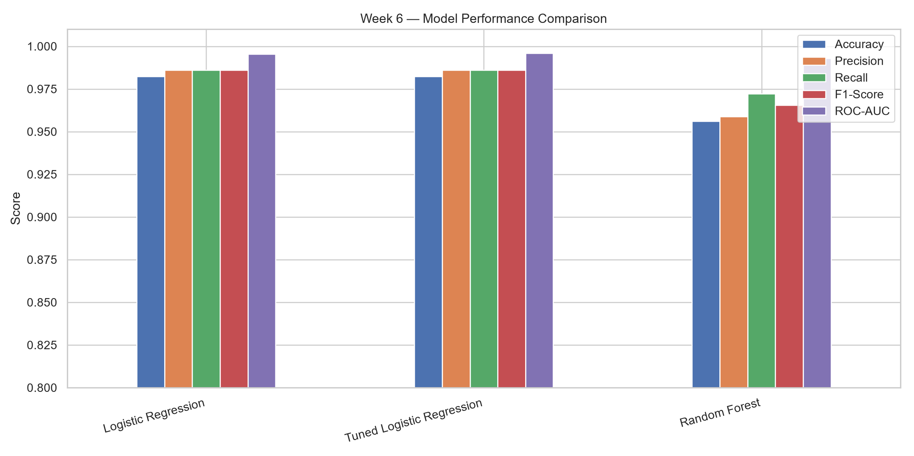
The chart should be interpreted alongside the numerical comparison table. Differences between the models indicate how their performance varies across the selected metrics. The preferred model should be identified using the recorded results and the evaluation objectives, rather than accuracy alone.

10.2 Final Model Evaluation:
- Reference files:
- report/final_evaluation_metrics.csv
- report/evaluation_report.txt

The final tuned Logistic Regression model is evaluated on the held-out test set. Its recorded scores summarize the overall classification performance and the balance between precision and recall.
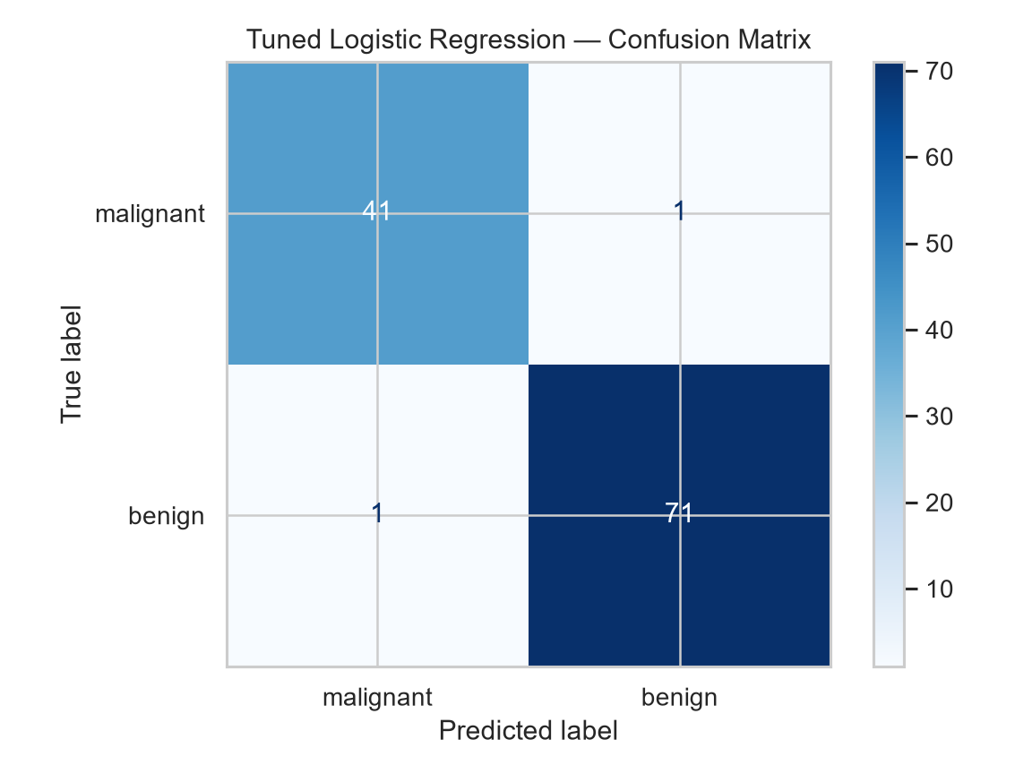
The confusion matrix should be examined to determine how many observations from each actual class were assigned to each predicted class. It complements the summary metrics by showing the distribution of classification errors.

10.3 ROC Curve Analysis:
The ROC curve illustrates the relationship between the true-positive rate and false-positive rate as the classification threshold changes. The diagonal reference line represents the performance of a random ranking baseline.
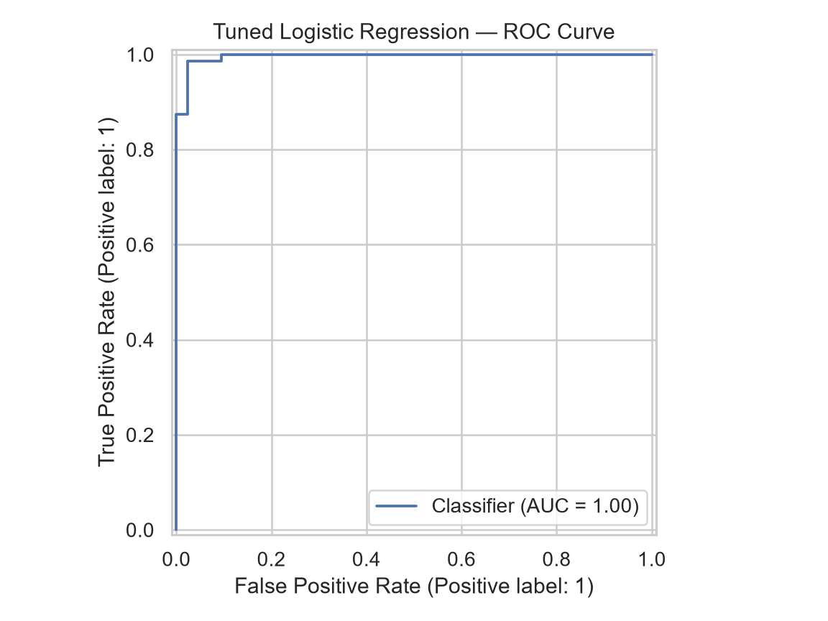
The ROC curve provides a threshold-independent view of the model's ranking performance. Its interpretation should be supported by the measured ROC-AUC value recorded in the final evaluation files.

10.4 Results Interpretation:
The comparison chart, confusion matrix, ROC curve, and CSV metrics provide complementary views of model performance.
Accuracy summarizes overall correctness. Precision, recall, and F1-score provide additional information about class-level prediction performance. The confusion matrix identifies the distribution of classification errors, while ROC-AUC summarizes ranking discrimination across thresholds.
The cross-validation score used during hyperparameter selection must be distinguished from the final test-set metrics. The former guides model selection; the latter evaluates the selected estimator on held-out observations.
No clinical conclusions can be drawn from these results. The dataset and experimental design support an educational machine learning demonstration, not a validated diagnostic application.

11. Future Enhancements :

- Comparing additional classification algorithms.
- Investigating feature importance and feature selection.
- Evaluating class-specific performance across multiple validation splits.
- Assessing probability calibration and model robustness.
- Testing on independent datasets where appropriate access and permissions are available.
- Improving input validation and application error handling.
- Enhancing reproducibility through dependency version tracking and automated tests.
- Establishing appropriate privacy, governance, and clinical validation processes before considering any medical application.
- These items are potential improvements and are not claimed as completed features.

12. Conclusion :
The Breast Cancer Diagnostic Prediction System demonstrates a complete machine learning classification workflow using Python, Pandas, NumPy, and Scikit-learn. The implementation covers dataset exploration, preprocessing, model training, performance comparison, hyperparameter tuning, evaluation, visualization, and model serialization.
The completed implementation brings together core machine learning concepts and practical software development into a structured educational project. Its performance must be understood within the limitations of the dataset and evaluation design. It is not a clinically validated diagnostic system and must not be used for medical decisions.

